Worksheet 1

Student Name: Sujal Dhiman UID: 25MCA20186
Branch: MCA Section/Group: MCA1(A)
Semester: 2nd Date of Performance: 06/01/2026
Subject Name: Technical Training Subject Code: 25CAP-652

AIM:
To design and implement a sample database system using DDL, DML, and DCL commands, including database creation, data manipulation, schema modification, and role-based access control to ensure data integrity and secure, read-only access for authorized users.
Objective:
To gain practical experience in implementing Data Definition Language (DDL), Data Manipulation Language (DML), and Data Control Language (DCL) operations in a real database environment. This will also include implementing role-based privileges to secure data

Coding:
CREATE TABLE Division ( division_id INT PRIMARY KEY,
division_name VARCHAR(30) UNIQUE NOT NULL
);

CREATE TABLE Staff (
staff_id INT PRIMARY KEY, staff_name VARCHAR(30) NOT NULL, pay INT CHECK (pay > 0),

division_id INT,
CONSTRAINT fk_div FOREIGN KEY (division_id) REFERENCES Division(division_id)
);

CREATE TABLE Assignment ( assignment_id INT PRIMARY KEY, assignment_title VARCHAR(30) NOT NULL, division_id INT,
CONSTRAINT fk_assign_div FOREIGN KEY (division_id) REFERENCES Division(division_id)
);

INSERT INTO Division VALUES (10, 'ADMIN'),
(20, 'ACCOUNTS'),
(30, 'TECH'),
(40, 'MARKETING');

INSERT INTO Staff VALUES (501, 'RAVI SHARMA', 60000, 20),
(502, 'NEHA VERMA', 48000, 10),
(503, 'ARJUN MEHTA', 52000, 30),
(504, 'PRIYA GUPTA', 55000, 40);

INSERT INTO Assignment VALUES (901, 'Budget Planning', 20),

(902, 'System Upgrade', 30),
(903, 'Client Outreach', 40);

UPDATE Staff SET pay = 51000
WHERE staff_id = 502;

DELETE FROM Assignment WHERE assignment_id = 902;

SELECT CURRENT_USER;

CREATE ROLE view_only_staff WITH LOGIN PASSWORD 'view123';

SELECT CURRENT_USER;

GRANT SELECT ON Division TO view_only_staff; GRANT SELECT ON Staff TO view_only_staff; GRANT SELECT ON Assignment TO view_only_staff;

REVOKE CREATE ON SCHEMA public FROM view_only_staff;
REVOKE INSERT, UPDATE, DELETE ON Division FROM view_only_staff; REVOKE INSERT, UPDATE, DELETE ON Staff FROM view_only_staff; REVOKE INSERT, UPDATE, DELETE ON Assignment FROM view_only_staff;

ALTER TABLE Assignment
ALTER COLUMN assignment_title TYPE VARCHAR(100); DROP TABLE Assignment;
SELECT * FROM division; SELECT * FROM assignment; SELECT * FROM staff;

OUTPUT :
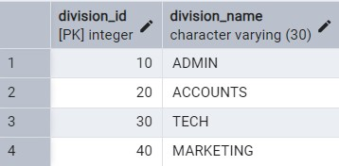
Fig 1.1: Division Table
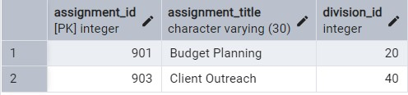
Fig 1.2: Assignment Table
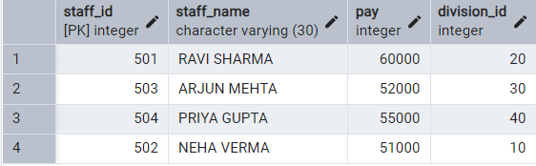
Fig 1.2: Staff Table

- Learning outcomes (What I have learnt) :
  - Understand the working principle of the Quick Sort algorithm, including pivot selection, partitioning, and recursive sorting.
  - Analyze the time complexity of Quick Sort in best, average, and worst cases, and relate it to practical runtime measurements in Python.
  - Implement Quick Sort using recursion in Python, including correct handling of indices and in-place array manipulation.
  - Evaluate algorithm performance by measuring execution time, interpreting results using Python’s time
module.
  - Compare sorted and original datasets, demonstrating the correctness of the algorithm and reinforcing debugging and verification skills.

- Evaluation Grid :

Sr. No. | Parameters | Marks Obtained | Maximum Marks
1. | Worksheet Completion |  | 08 marks
2. | Conduct |  | 12 marks
3. | Viva Voice |  | 10 marks
4. | Total |  | 30 marks

